**Session by Session Procedures**

Client name:_________________ Registered Nurse: __________________

Session 3

|  |  |  |
| --- | --- | --- |
| **DATE** | **PROCEDURE** | **MATERIALS** |
| **__ /__ /__**  **Time**  **Provided**  **Time In:**  **Time Out:**  **Mileage:**  **Driving Time:** | **PREPARATION for SESSION 3**   * Complete Medication Calendar * Review issues/goals addressed in second session   **INTRODUCTION**   * Introduce session goal * Locate CAPABLE Folder * Confirm that client understands and agrees to participate   **SESSION CONTENT**   * Complete Brainstorming/Problem-solving process * Continue to develop Action Plans with client * Review/assess/trouble-shoot CAPABLE exercises * Assess need to contact Healthcare Provider or evaluate response to communication * Refer to CAPABLE Folder as needed | * Client chart * Session 3 form * Action Plans * Brainstorming worksheet * Health Passport * CAPABLE Folder   **CLOSURE**   * Review key session activities and points * Explain next session is last RN visit * Schedule next session, record in CAPABLE calendar   **POST-SESSION PLANNING**   * Complete any unfinished business, i.e.- medication calendar, PCP contact or research client concerns * Other: |
| ***NOTES:***   |  | | --- | | **Communication with Healthcare Providers:**  Method of communication?  Healthcare Provider response *(Try to get response according to client, in order to assess effectiveness of provider/patient communication. If RN spoke with Healthcare Provider then the response will be per RN.)*: | | |
| **POST-SESSION CLINICAL REASONING PROCESS** | | | | |
| **Action Taken:**   |  |  |  |  | | --- | --- | --- | --- | | **Target Area Addressed** | **Successful**  **Strategies** | **Goals** | **Targeted Problem Area Status**  1=a lot worse  2=a little worse  3=the same  4=a little better  5=a lot better | | * **Pain** |  |  |  | | * **Mood** |  |  |  | | * **Fall**   **Prevention** |  |  |  | | * **Incontinence** |  |  |  | | * **Medications** |  |  |  | | * **PCP Advocacy/**   **Support** |  |  |  | | * Other: |  |  |  | | * Other: |  |  |  |   **Universal Nurse Offerings**  Sometimes the client works with the nurse on a problem but does not want to identify the issue as a “target area”. This is what CAPABLE calls “Universal Nurse Offerings”. For example, the nurse offers to make a medication calendar and reviews medications for safety, with clients who are interested, even though the client does not identify medications as a target area.   |  |  |  | | --- | --- | --- | | **Universal RN Offerings** | **Client Engagement?**  **YES/NO** | **Details** | | **Medication Management** *(Medication Calendar, side effect/interactions check, evaluate for high alert meds)* |  |  | | **CAPABLE Exercises** |  |  | | **Health Passport** |  |  |   **Homework for RN:**  **Homework for Client:**  **Probing Questions:**  Has your view of the client’s situation changed?  Do you think the client’s view of his/her situation has changed?  What is your plan for the next session?  **Medication Assessment (*consider pharmacist consult as per protocol)*:**   * + 1. Number of high alert medications _____.     2. Does client have any questions or concerns about medications?   3. Is client complaining of any symptoms that could be side effects to medications?  4. Any changes in medication regimen? *(details on changes)*:  **OT Update** *(Record any communication between nurse and OT)***:** | | | | |
|  | | | | |

|  |
| --- |
| **DISCOMFORT/PAIN ASSESSMENT** |
| Does client report problems with pain, discomfort, tightness, and soreness? *(Many older adults do not identify discomfort as pain but often they want to find relief for their “tightness, soreness or discomfort”).*  **YES NO** |
| Circle and number each painful area of client on figures below. Prioritize location by giving client’s worst pain #1 and least painful location #5. *(Some people are very specific about their pain and others view their pain as very general, evaluate and plan accordingly).* |

|  |  |  |
| --- | --- | --- |
| **Pain Identified on Session 2** | | |
| **Location** | **Pain Rating** | |
| At rest | With movement |
| 1. |  |  |
| 2. |  |  |
| 3. |  |  |
| 4. |  |  |

|  |  |  |
| --- | --- | --- |
| **Pain Identified on Session 1** | | |
| **Location** | **Pain Rating** | |
| At rest | With movement |
| 1. |  |  |
| 2. |  |  |
| 3. |  |  |
| 4. |  |  |

Client rate discomfort/pain at primary site, intensity or severity:

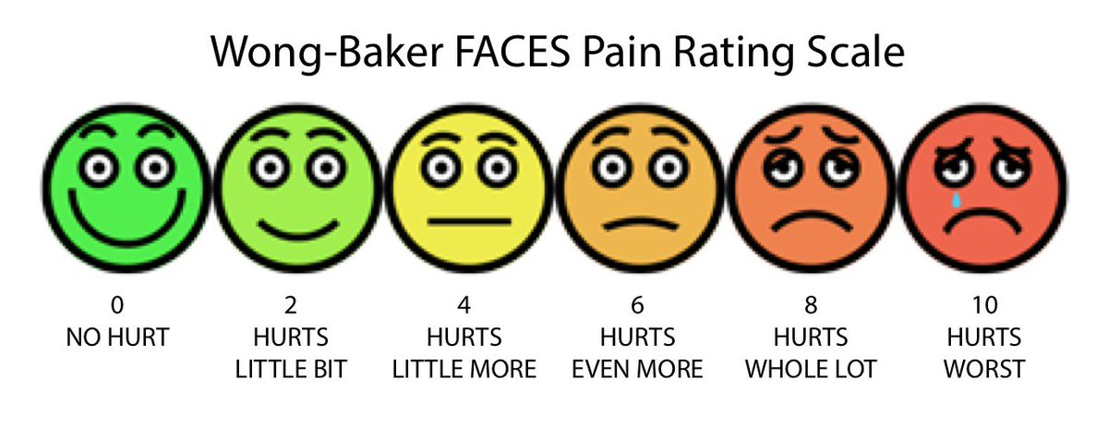

| | | | | | | | | | | | | | | | | | | | |

|  |  |  |  |  |  |  |  |  |  |  |
| --- | --- | --- | --- | --- | --- | --- | --- | --- | --- | --- |
| **0** | 1 | 2 | 3 | 4 | **5** | 6 | 7 | 8 | 9 | **10** |
| no pain |  |  |  |  | moderate pain |  |  |  |  | severe pain |
|  |  |  |  |  |  |  |  |  |  |  |

|  |  |  |  |  |
| --- | --- | --- | --- | --- |
| List painful areas below include cause of discomfort/pain, and description. | | | | |
| **Location** *(#1 should be location of worst pain, #5 should be location of least pain)* | **Pain Rating** *(see scale below)* | | **Cause** | **Description** *(aching, crushing, sharp, burning, heavy, throbbing, stiffness, dull, radiating, nagging, stabbing, tingling, cramping, numbness)* |
| At rest | With Movement |
| 1. |  |  |  |  |
| 2. |  |  |  |  |
| 3. |  |  |  |  |
|  |  |  |  |  |

|  |  |  |  |
| --- | --- | --- | --- |
| **Pain Location** | **Strategies Tried**  *(heat, ice, medicine, hot bath, TENS machine, exercise, etc.)* | **Success of Strategies**  **1**=successful  **2**=somewhat successful  **3**=not successful | **Target Area Status**  **1**=a lot worse  **2**=a little worse  **3**=the same  **4**=a little better  **5**=a lot better |
|  |  |  |  |
|  |  |  |  |
|  |  |  |  |
|  |  |  |  |
|  |  |  |  |
|  |  |  |  |
|  |  |  |  |